|  |  |  |  |  |
| --- | --- | --- | --- | --- |
| EGC_Black | | Mathematics Essentials 2015  Test 3 Unit 2  Task Weighting: 14% | | |
| Student Name: |  | |  |

Time Allowed: 50 Minutes Total Marks: 48

**Calculators and files are allowed in this test.**

***Answer all of the following questions. Show all working to maximise marks.***

**Question 1** [4 Marks: 2, 2]

1. Convert the following times to 12 hour time  
     
   1. 1045 h \_\_\_\_\_\_\_\_\_\_\_\_\_\_\_
   2. 2331 h \_\_\_\_\_\_\_\_\_\_\_\_\_\_\_
2. Convert the following times to 24 hour time  
     
   1. 4:25 p.m. \_\_\_\_\_\_\_\_\_\_\_\_\_\_\_
   2. 6:35 a.m. \_\_\_\_\_\_\_\_\_\_\_\_\_\_\_

**Question 2** [3 Marks: 1, 2]

1. Vanessa’s flight lands in Singapore at 0840. Her next flight leaves Singapore at 1820. How long does Vanessa have in the Singapore airport?

1. Peter wants to go for a bike ride which takes 52 minutes. He also wants to watch his favourite television show which starts at 7:35 p.m. What is the latest time that he can leave for his bike ride and be back in time to watch television?

**Question 3 (5 marks – 1, 2, 2)**

At Eastern Goldfields College,Period 1 starts at 8:20 am every morning.

1. If Holly wakes up an hour and a half before school starts, what time does she wake up?
2. How much time has elapsed from the start of Period 1 to Lunch 2 at 12:45 pm?
3. If school finishes at 3:15 pm and Tara starts work 1 hour and 55 minutes later, what time does she begin work?

**Question 4 ( 5 – 1, 1, 1, 2)**

1. Convert this graphical scale into a fractional scale (i. e. 1: \_\_\_\_\_\_\_\_\_\_)

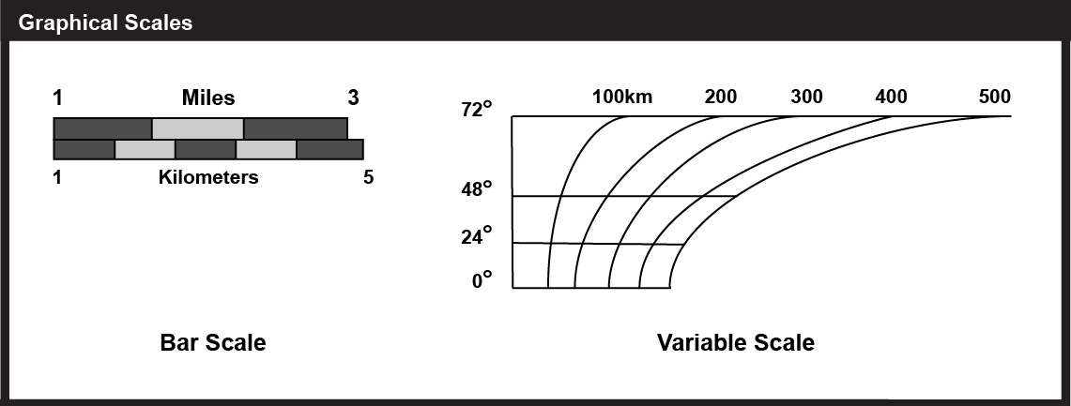

**0**

1. 1 cm to 200 m can be written as 1: \_\_\_\_\_\_\_\_\_\_\_\_\_\_
2. A map scale of 1 : 3000 means 1 cm on the map represents \_\_\_\_\_\_\_\_\_\_\_\_\_\_\_ metres in real life
3. If the length of a room was 5.6 m and the floor plan scale was 1:80, how long

would the line be drawn on the plan?

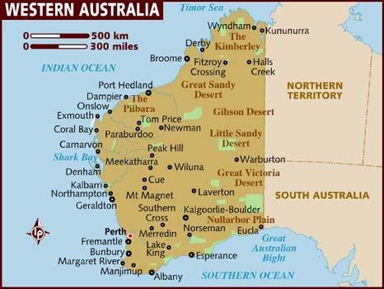**Question 5** [8 Marks – 2, 1, 2, 2, 1 ]

1. What is the scale? (Write the graphical scale as a fractional scale)
2. Explain why we would only use the kilometre units provided by the scale.
3. The approximate distance from Perth to Broome is 1680 km. Explain, using the scale and with calculations, how this result has been obtained.
4. Use the map to estimate the distance between Albany and Eucla
5. Is your answer to d) a good estimate of the road distance between Albany and Eucla? Explain your answer.

**Question 6** [ 9 Marks: 1, 3, 2, 1, 2]   
  
You are planning a road trip to Broome. We are assuming that you can maintain an average speed of 100 km/h on these roads.

1. How long will it take to travel this distance? Give your answer in hours correct to 1 d.p.

We can assume that a medium sized car uses 9L/100km and a four wheel drive uses 14L/100km and that you will pay around $1.40 per litre for fuel.

**٭ 9L/100km means for every 100km travelled, the car uses 9 Litres of fuel.**

1. Calculate the cost of your trip using a medium sized car, showing your working.
2. Calculate the cost of your trip using a four wheel drive, showing your working.
3. What is the difference in cost between using a four wheel drive compared to a medium sized car?
4. What percentage is the cost of the medium sized car to that of the four wheel drive? Show your working.

**Question 7** [6 Marks – 2, 2, 2 ]   
  
This is the timetable for the Rottnest Express ferry.

Timetable Travelling to Rottnest Island Friday, October 30, 2015

|  |  |  |  |
| --- | --- | --- | --- |
| **Boarding Closes** | **From** | **To** | **Remarks** |
| 07:15 | B-Shed Fremantle | Rottnest Island | Direct service from B Shed to Rottnest |
| 08:30 | Barrack St, Perth | Rottnest Island | Service travels from Perth via Northport to Rottnest |
| 10:00 | Northport Fremantle | Rottnest Island | Service travels from Perth via Northport to Rottnest |
| 09:30 | B-Shed Fremantle | Rottnest Island | Direct service from B Shed to Rottnest |
| 11:30 | B-Shed Fremantle | Rottnest Island | Direct service from B Shed to Rottnest |
| 13:45 | Northport Fremantle | Rottnest Island | Direct service from Northport to Rottnest |
| 15:15 | B-Shed Fremantle | Rottnest Island | Direct service from B Shed to Rottnest |
| 17:45 | B-Shed Fremantle | Rottnest Island | Service travels from B Shed via Northport to Rottnest |
| 18:15 | Northport Fremantle | Rottnest Island | Service travels from B Shed via Northport to Rottnest |

Timetable Travelling from Rottnest Island Friday, October 30, 2015

|  |  |  |  |
| --- | --- | --- | --- |
| **Boarding Closes** | **From** | **To** | **Remarks** |
| 08:25 | Rottnest Island | Northport Fremantle | Service travels to B Shed via Northport |
| 08:25 | Rottnest Island | B-Shed Fremantle | Service travels to B Shed via Northport |
| 10:40 | Rottnest Island | B-Shed Fremantle | Direct service to Bshed |
| 11:40 | Rottnest Island | Northport Fremantle | Direct service to Northport |
| 14:10 | Rottnest Island | Northport Fremantle | Service travels to B Shed via Northport |
| 14:10 | Rottnest Island | B-Shed Fremantle | Service travels to B Shed via Northport |
| 15:55 | Rottnest Island | Northport Fremantle | Service travels to Northport, B Shed and Perth |
| 15:55 | Rottnest Island | B-Shed Fremantle | Service travels to Northport, B Shed and Perth |
| 15:55 | Rottnest Island | Barrack St, Perth | Service travels to Northport, B Shed and Perth |
| 16:25 | Rottnest Island | B-Shed Fremantle | Direct Service from Rottnest to Bshed |
| 19:10 | Rottnest Island | B-Shed Fremantle | Service travels to Northport via B Shed |
| 19:10 | Rottnest Island | Northport Fremantle | Service travels to Northport via B Shed |

All times in Australian Western Standard Time.

<https://www.rottnestexpress.com.au/ferry-timetable>

1. Pauline hopes to park her car at Northport while she spends the day at Rottnest. Which ferries should she choose to allow maximum time on the island?
2. Gary intends to catch a bus to Barrack St in Perth to allow him to catch the ferry. Which ferries should he use to allow himself maximum time on the island?
3. Claudia has a dentist appointment at 10am, then plans to go to B shed to catch a ferry. Which ones can she catch to spend the most time on Rottnest?

**Question 6** [8 Marks: 1, 1, 3, 2, 1]

The following graph gives the distance of a cyclist form his home

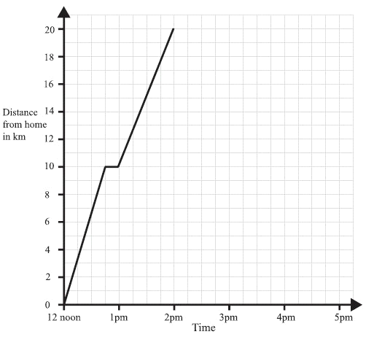

a) For how long did he rest?

b) How far away from home was he at 1.30 pm?

c) Find his speed in kilometres per hour through: (Round answers to 1 d.p. if necessary)

(i) Section A

(ii) Section B

d) What was his ‘average’ speed for the entire bike ride?

e) How can you tell from the graph when the cyclist was travelling most quickly?